Project 3 documentation.

There are several comparison given for sorting technique in project 3.

I have included header files such as
#include<algorithm>//For reversing function
#include<stdlib.h>//For generating random number using standard library
I have created class for sorting technique. “class Sorting_tech”

By using this class I have created functions such as
void selection_Sort(int array_data[], int nsize)// Selection sort algorithm
void insertion_Sort(int array_data[], int nsize)//Insertion sort algorithm
void bubble_sort(int array_data[], int nsize)//bubble sort algorithm
void generateRandomNumbers(int data[],int nsize)
void reverse_random_order(int array_data[], int nsize)

Each functions perform according to the given logic.

Main function call the each function by using its object created in the main class. On the same time clock has been set for the each sorting algorithm and calculated the time for operation. Individual sorting technique generates the results and compare the smallest amount to display the result

Surprising: When you are performing any operation on small number of values like 10 or 20 values the clock time gives you the smallest output and it will generate milliseconds value. But When you increases the numbers, as a input size 100000, it gives you some different time calculations such as Insertion sort was best for big number of values and Bubble sort is good for small number of values.

I have included the library for reversing the number and it generates reverse values that has been generated by random number generation function.

Time complexity
Selection sort : pick the smallest number and append it to the result of the given input
Insertion sort : It rapidly add the element to the sorted list of array elements
Bubble sort: Rapidly compar the pair values besides given value and swap the function with each elements

Following is the output for the given sorting technique for small size array

Figure 1. Project 3 (Sorting techniques) with 100 values

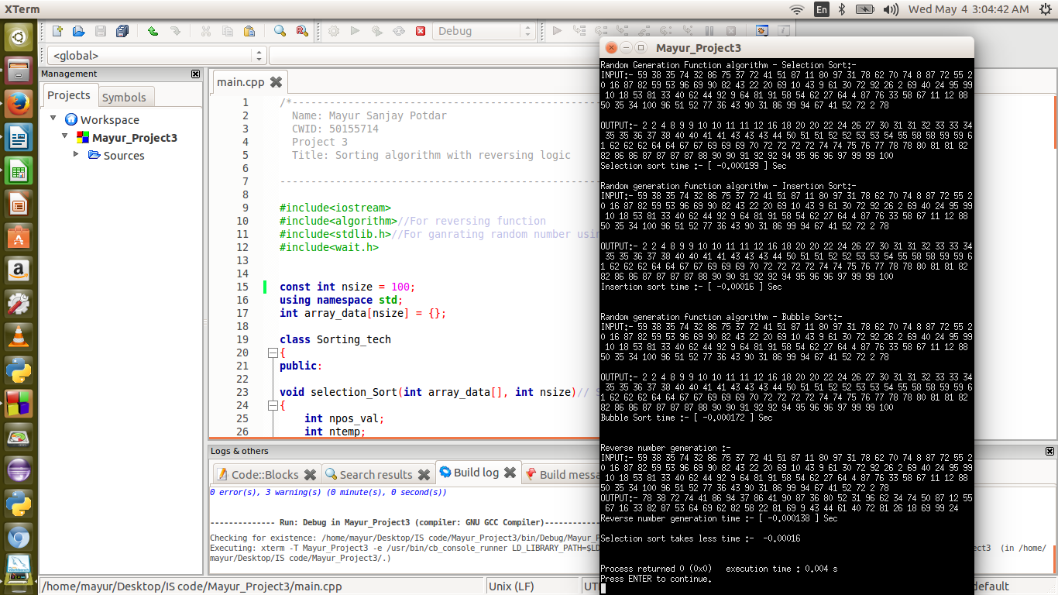
Figure 2 10 number number of values
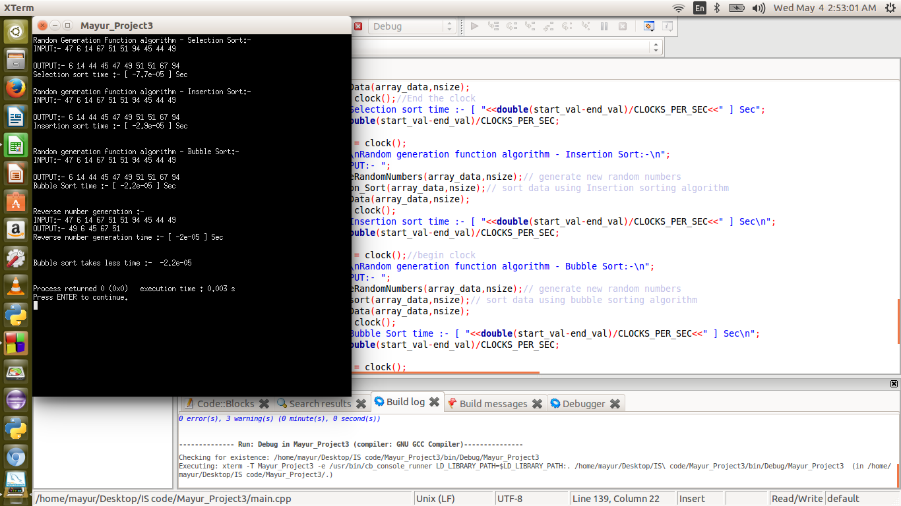
Figure 3. 10000 values results
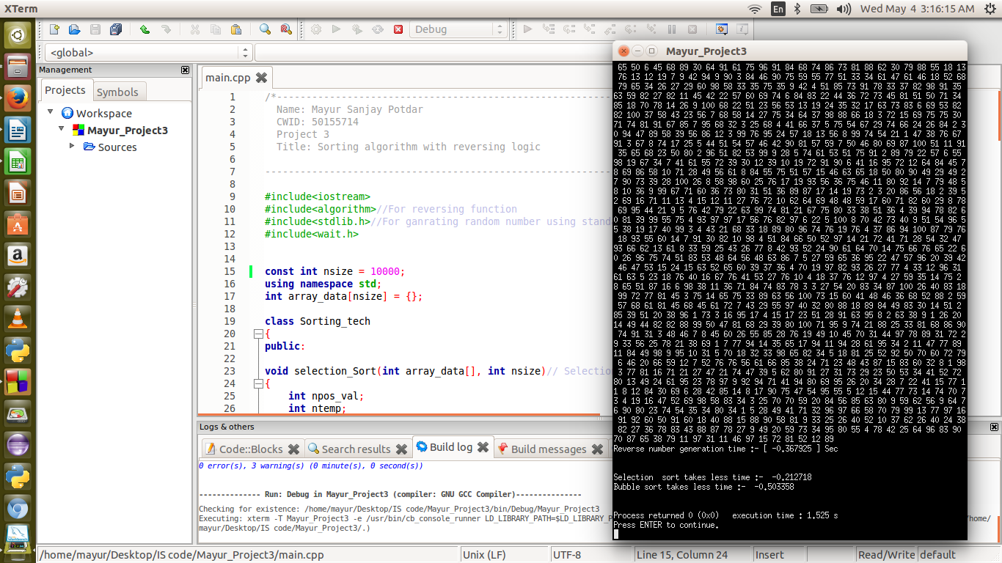

Result Analysis:

For first 10 values Bubble sort was fast, Time gap in Graph Analysis
For next 100 values Insertion sort was best, Values given in Graph Analysis
For next 1000 values Bubble sort was best, Time given in Graph Analysis
For next 10000 values Selection sort was fast, Values and Time given in Graph Analysis
Finally, 100000 values Insertion sort was fast, Time given in Graph Analysis

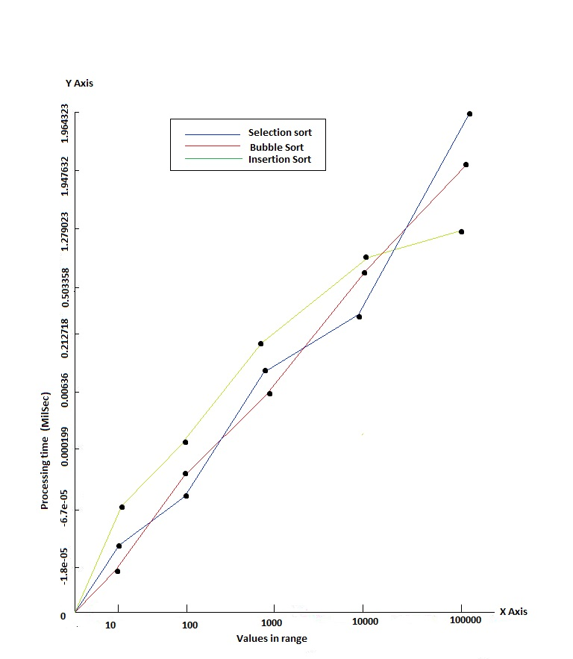
CONCLUSION :-
I can conclude that the Bubble sort is best for small numbers sorting, as for large number insertion sort is best.

